Digital Nurture 4.0 – Week 5
Microservices

(a) Mandatory hands-on
Filename : 2. Microservices with API gateway
1.Create a Spring Web Project using Spring Initializr:
Step 1:
Create a spring boot project named account.Refer below details

  - Project: Maven
  - Language: Java
  - Spring Boot: 3.5.3
  - Group: com.cognizant
  - Artifact: account
  - Name: account
  - Package Name: com.cognizant.account
  - Packaging: Jar
  - Java version: 24
Dependencies:
  - Spring Boot DevTools
  - Spring Web

Step 2:
Create the package named controller and also create class named AccountController.java.And alter application.properties and AccountApplication.java.
AccountApplication.java:
package com.cognizant.account;

import org.springframework.boot.SpringApplication;
import org.springframework.boot.autoconfigure.SpringBootApplication;

@SpringBootApplication
public class AccountApplication {
public static void main(String[] args) {
SpringApplication.run(AccountApplication.class, args);
}
}

AccountController.java:
package com.cognizant.account.controller;

import org.springframework.web.bind.annotation.*;

import java.util.Map;

@RestController
@RequestMapping("/accounts")
public class AccountController {

@GetMapping("/{number}")
public Map<String, Object> getAccount(@PathVariable String number) {
return Map.of(
"number", number,
"type", "savings",
"balance", 234343
);
}
}

application.properties:
server.port=8080
spring.application.name=account-service

Step 3:
Run AccountApplication.java as a java application.
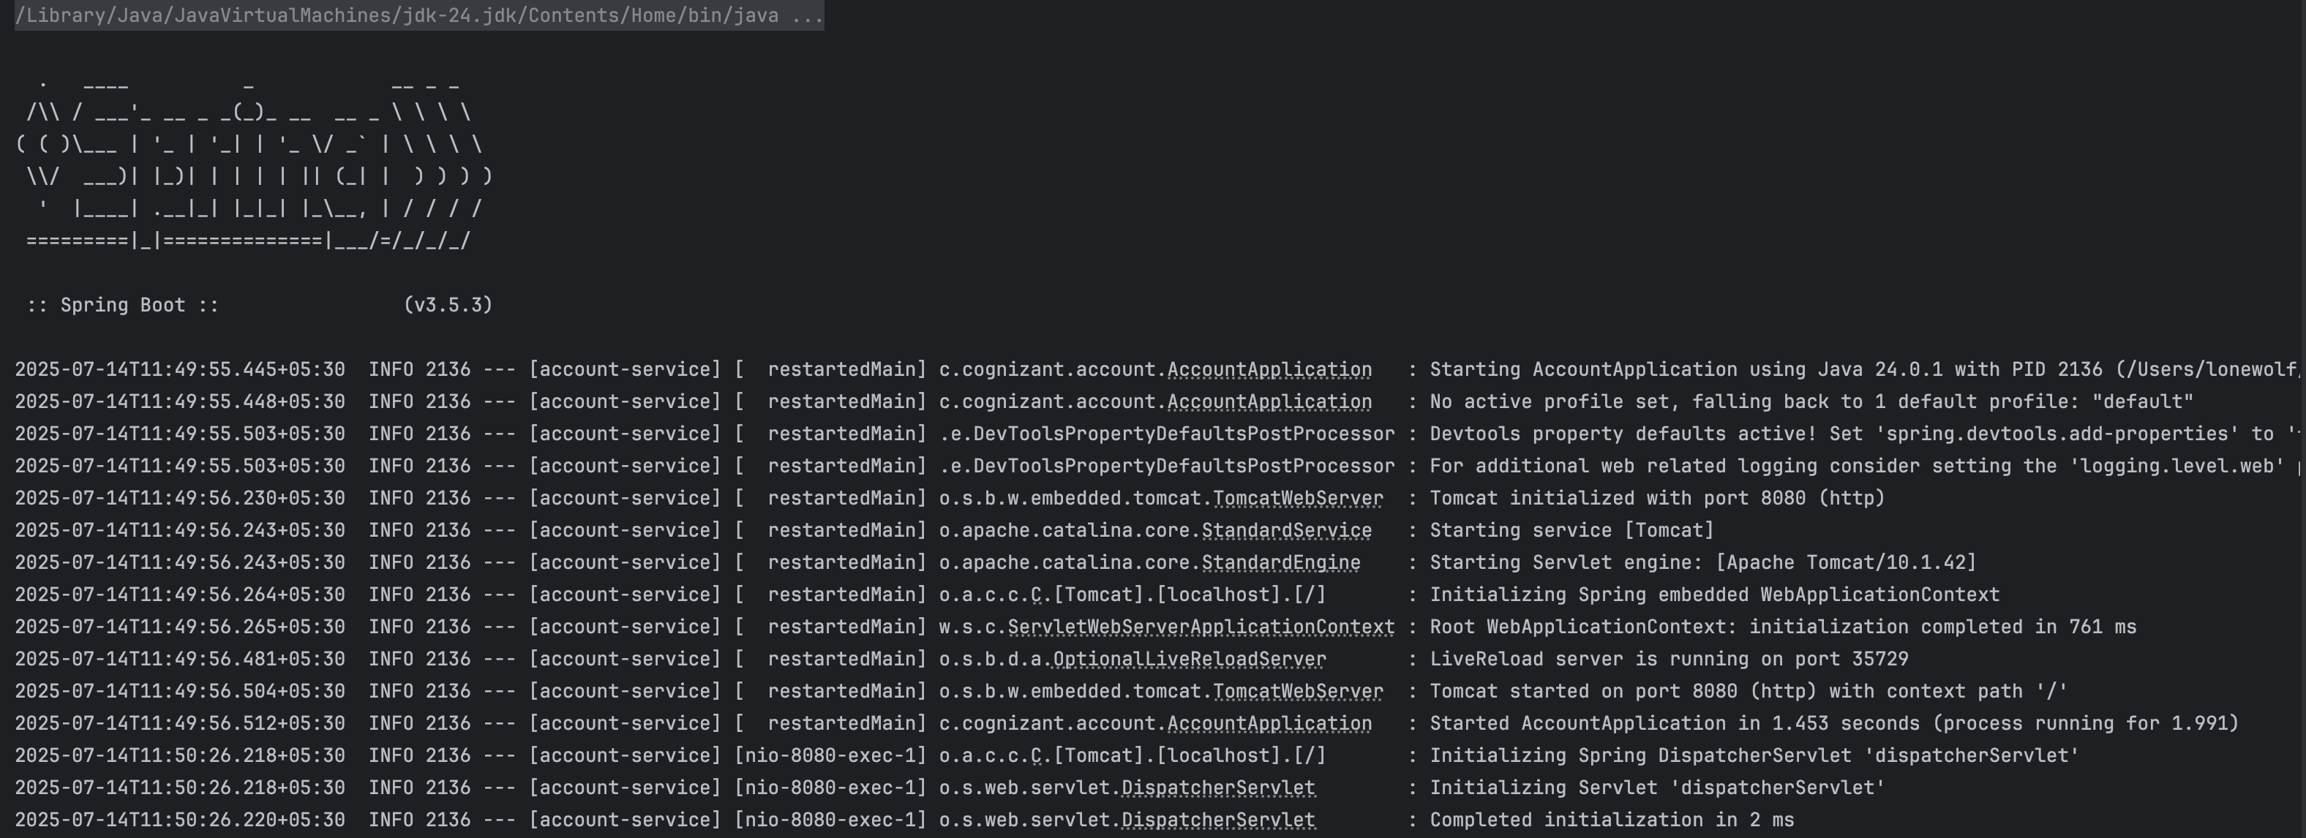
Run http://localhost:8080/accounts/00987987973432 in GET method by using postman.
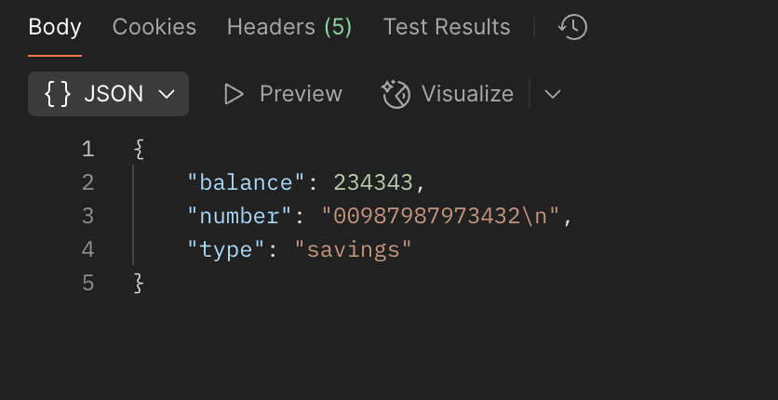

Step 4:
Create a spring boot project named loan.Refer below details

  - Project: Maven
  - Language: Java
  - Spring Boot: 3.5.3
  - Group: com.cognizant
  - Artifact: loan
  - Name: loan
  - Package Name: com.cognizant.loan
  - Packaging: Jar
  - Java version: 24
Dependencies:
  - Spring Boot DevTools
  - Spring Web
Step 5:
Create the package named controller and also create class named LoanController.java.And alter application.properties and LoanApplication.java.

LoanController.java:
package com.cognizant.loan.controller;

import org.springframework.web.bind.annotation.*;

import java.util.Map;

@RestController
@RequestMapping("/loans")
public class LoanController {

@GetMapping("/{number}")
public Map<String, Object> getLoan(@PathVariable String number) {
return Map.of(
"number", number,
"type", "car",
"loan", 400000,
"emi", 3258,
"tenure", 18
);
}
}

LoanApplication.java:
package com.cognizant.loan;

import org.springframework.boot.SpringApplication;
import org.springframework.boot.autoconfigure.SpringBootApplication;

@SpringBootApplication
public class LoanApplication {
public static void main(String[] args) {
SpringApplication.run(LoanApplication.class, args);
}
}

application.properties:
server.port=8081
spring.application.name=loan-service

Step 6:
Run LoanApplication.java as a java application.
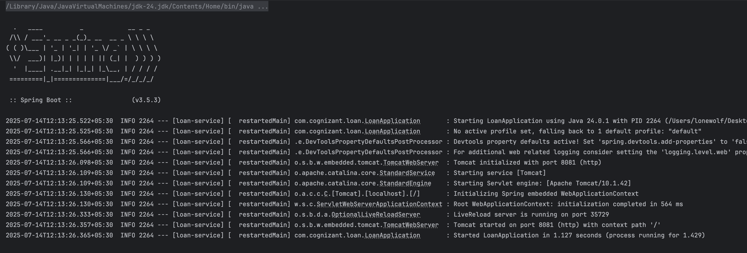

Run http://localhost:8081/loans/H00987987972342 in GET method by using postman.

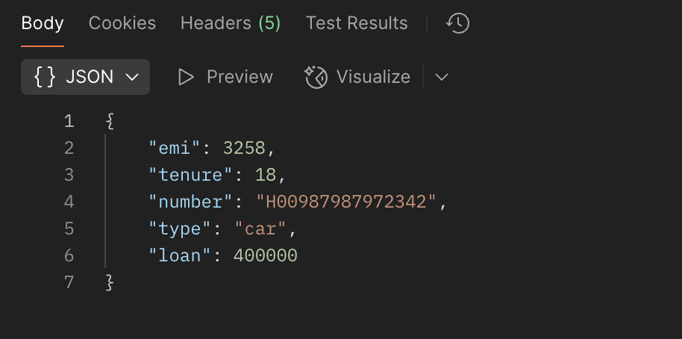

(b) Additional important hands-on
Filename : 2. Microservices with API gateway

2.Create Eureka Discovery Server and register
Step 1:
Create a spring boot project named account.Refer below details

  - Project: Maven
  - Language: Java
  - Spring Boot: 3.2.4
  - Group: com.cognizant
  - Artifact: eurekaserver
  - Name: eurekaserver
  - Package Name: com.cognizant.eurekaserver
  - Packaging: Jar
  - Java version: 17
Dependencies:
  - Spring Boot DevTools
  - Eureka Server

Step 2:
Make changes on pom.xml,application.properties,EurekaServerApplication.java.

pom.xml:
<project xmlns="http://maven.apache.org/POM/4.0.0"
xmlns:xsi="http://www.w3.org/2001/XMLSchema-instance"
xsi:schemaLocation="http://maven.apache.org/POM/4.0.0
https://maven.apache.org/xsd/maven-4.0.0.xsd">

<modelVersion>4.0.0</modelVersion>

<parent>
<groupId>org.springframework.boot</groupId>
<artifactId>spring-boot-starter-parent</artifactId>
<version>3.2.4</version>
<relativePath/>
</parent>

<groupId>com.cognizant</groupId>
<artifactId>eureka-server</artifactId>
<version>0.0.1-SNAPSHOT</version>
<name>eureka-server</name>
<description>Eureka Server for service registry</description>

<properties>
<java.version>17</java.version>
<spring-cloud.version>2023.0.1</spring-cloud.version>
</properties>

<dependencies>
<dependency>
<groupId>org.springframework.cloud</groupId>
<artifactId>spring-cloud-starter-netflix-eureka-server</artifactId>
</dependency>
<dependency>
<groupId>org.springframework.boot</groupId>
<artifactId>spring-boot-starter-web</artifactId>
</dependency>

<dependency>
<groupId>org.springframework.boot</groupId>
<artifactId>spring-boot-devtools</artifactId>
<scope>runtime</scope>
<optional>true</optional>
</dependency>

<dependency>
<groupId>org.springframework.boot</groupId>
<artifactId>spring-boot-starter-test</artifactId>
<scope>test</scope>
</dependency>
</dependencies>

<dependencyManagement>
<dependencies>
<dependency>
<groupId>org.springframework.cloud</groupId>
<artifactId>spring-cloud-dependencies</artifactId>
<version>${spring-cloud.version}</version>
<type>pom</type>
<scope>import</scope>
</dependency>
</dependencies>
</dependencyManagement>

<build>
<plugins>
<plugin>
<groupId>org.springframework.boot</groupId>
<artifactId>spring-boot-maven-plugin</artifactId>
</plugin>
</plugins>
</build>
</project>

application.properties:
server.port=8761
spring.application.name=EUREKA-SERVER
eureka.client.register-with-eureka=false
eureka.client.fetch-registry=false

EurekaServerApplication.java:
package com.cognizant.eurekaserver;

import org.springframework.boot.SpringApplication;
import org.springframework.boot.autoconfigure.SpringBootApplication;
import org.springframework.cloud.netflix.eureka.server.EnableEurekaServer;

@SpringBootApplication
@EnableEurekaServer
public class EurekaServerApplication {
public static void main(String[] args) {
SpringApplication.run(EurekaServerApplication.class, args);
}
}

Step 3:
Now run EurekaServerApplication.java as a java application and run http://localhost:8761/ on your brower.After run account and loan server the final output will be shows in the end.

Step 4:
Create a spring boot project named account.Refer below details

  - Project: Maven
  - Language: Java
  - Spring Boot: 3.2.4
  - Group: com.cognizant
  - Artifact: account
  - Name: account
  - Package Name: com.cognizant.account
  - Packaging: Jar
  - Java version: 17
Dependencies:
  - Spring Boot DevTools
  - Spring Web
  - Eureka Discovery Client

Step 5:
Create the package named controller and also create class named AccountController.java.Alter application.properties,AccountApplication.java and ensure pom.xml.

AccountController.java:
package com.cognizant.account.controller;

import org.springframework.web.bind.annotation.GetMapping;
import org.springframework.web.bind.annotation.RequestMapping;
import org.springframework.web.bind.annotation.RestController;

import java.util.Map;

@RestController
@RequestMapping("/account")
public class AccountController {

@GetMapping("/details")
public Map<String, Object> getAccountDetails() {
return Map.of(
"accountNumber", "1234567890",
"accountHolder", "Jane Doe",
"balance", 5000.75,
"status", "ACTIVE"
);
}
}

pom.xml:
<project xmlns="http://maven.apache.org/POM/4.0.0"
xmlns:xsi="http://www.w3.org/2001/XMLSchema-instance"
xsi:schemaLocation="http://maven.apache.org/POM/4.0.0
https://maven.apache.org/xsd/maven-4.0.0.xsd">

<modelVersion>4.0.0</modelVersion>

<parent>
<groupId>org.springframework.boot</groupId>
<artifactId>spring-boot-starter-parent</artifactId>
<version>3.2.4</version>
<relativePath/>
</parent>

<groupId>com.cognizant</groupId>
<artifactId>account</artifactId>
<version>0.0.1-SNAPSHOT</version>
<name>account-service</name>
<description>Account Service with Eureka Client</description>

<properties>
<java.version>17</java.version>
<spring-cloud.version>2023.0.1</spring-cloud.version>
</properties>

<dependencies>
<dependency>
<groupId>org.springframework.boot</groupId>
<artifactId>spring-boot-starter-web</artifactId>
</dependency>

<dependency>
<groupId>org.springframework.cloud</groupId>
<artifactId>spring-cloud-starter-netflix-eureka-client</artifactId>
</dependency>

<dependency>
<groupId>org.springframework.boot</groupId>
<artifactId>spring-boot-devtools</artifactId>
<scope>runtime</scope>
<optional>true</optional>
</dependency>

<dependency>
<groupId>org.springframework.boot</groupId>
<artifactId>spring-boot-starter-test</artifactId>
<scope>test</scope>
</dependency>
</dependencies>

<dependencyManagement>
<dependencies>
<dependency>
<groupId>org.springframework.cloud</groupId>
<artifactId>spring-cloud-dependencies</artifactId>
<version>${spring-cloud.version}</version>
<type>pom</type>
<scope>import</scope>
</dependency>
</dependencies>
</dependencyManagement>

<build>
<plugins>
<plugin>
<groupId>org.springframework.boot</groupId>
<artifactId>spring-boot-maven-plugin</artifactId>
</plugin>
</plugins>
</build>
</project>

application.properties:
server.port=8081
spring.application.name=ACCOUNT-SERVICE

eureka.client.service-url.defaultZone=http://localhost:8761/eureka/
eureka.instance.prefer-ip-address=true

management.endpoints.web.exposure.include=*
management.endpoint.health.show-details=always

AccountApplication.java:
package com.cognizant.account;

import org.springframework.boot.SpringApplication;
import org.springframework.boot.autoconfigure.SpringBootApplication;
import org.springframework.cloud.netflix.eureka.EnableEurekaClient;

@SpringBootApplication
@EnableEurekaClient
public class AccountApplication {
public static void main(String[] args) {
SpringApplication.run(AccountApplication.class, args);
}
}

Step 6:
Run AccountApplication.java as a java application and run http://localhost:8081/account/details on your browser.
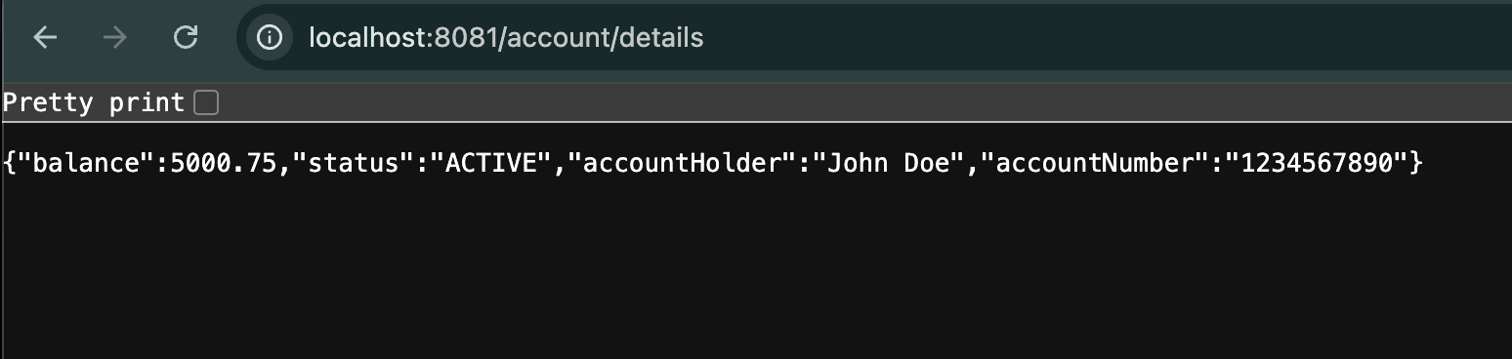

Step 7:
Create a spring boot project named account.Refer below details

  - Project: Maven
  - Language: Java
  - Spring Boot: 3.2.4
  - Group: com.cognizant
  - Artifact: loan
  - Name: loan
  - Package Name: com.cognizant.loan
  - Packaging: Jar
  - Java version: 17
Dependencies:
  - Spring Boot DevTools
  - Spring Web
  - Eureka Discovery Client
Step 8:
Create the package named controller and also create class named LoanController.java.And alter application.properties and LoanApplication.java.Finally ensure the pom.xml too.

pom.xml:
<project xmlns="http://maven.apache.org/POM/4.0.0"
xmlns:xsi="http://www.w3.org/2001/XMLSchema-instance"
xsi:schemaLocation="http://maven.apache.org/POM/4.0.0
https://maven.apache.org/xsd/maven-4.0.0.xsd">

<modelVersion>4.0.0</modelVersion>

<parent>
<groupId>org.springframework.boot</groupId>
<artifactId>spring-boot-starter-parent</artifactId>
<version>3.2.4</version>
<relativePath/>
</parent>

<groupId>com.cognizant</groupId>
<artifactId>loan</artifactId>
<version>0.0.1-SNAPSHOT</version>
<name>loan-service</name>
<description>Loan Service with Eureka Client</description>

<properties>
<java.version>17</java.version>
<spring-cloud.version>2023.0.1</spring-cloud.version>
</properties>

<dependencies>
<dependency>
<groupId>org.springframework.boot</groupId>
<artifactId>spring-boot-starter-web</artifactId>
</dependency>

<dependency>
<groupId>org.springframework.cloud</groupId>
<artifactId>spring-cloud-starter-netflix-eureka-client</artifactId>
</dependency>

<dependency>
<groupId>org.springframework.boot</groupId>
<artifactId>spring-boot-devtools</artifactId>
<scope>runtime</scope>
<optional>true</optional>
</dependency>

<dependency>
<groupId>org.springframework.boot</groupId>
<artifactId>spring-boot-starter-test</artifactId>
<scope>test</scope>
</dependency>
</dependencies>

<dependencyManagement>
<dependencies>
<dependency>
<groupId>org.springframework.cloud</groupId>
<artifactId>spring-cloud-dependencies</artifactId>
<version>${spring-cloud.version}</version>
<type>pom</type>
<scope>import</scope>
</dependency>
</dependencies>
</dependencyManagement>

<build>
<plugins>
<plugin>
<groupId>org.springframework.boot</groupId>
<artifactId>spring-boot-maven-plugin</artifactId>
</plugin>
</plugins>
</build>
</project>

LoanController.java:
package com.cognizant.loan.controller;
import org.springframework.web.bind.annotation.GetMapping;
import org.springframework.web.bind.annotation.RequestMapping;
import org.springframework.web.bind.annotation.RestController;
import java.util.Map;

@RestController
@RequestMapping("/loan")
public class LoanController {

@GetMapping("/details")
public Map<String, Object> getLoanDetails() {
return Map.of(
"loanId", "LN12345678",
"borrowerName", "John Smith",
"amount", 500000.0,
"interestRate", 7.5,
"status", "APPROVED"
);
}
}

LoanApplication.java:
package com.cognizant.loan;
import org.springframework.boot.SpringApplication;
import org.springframework.boot.autoconfigure.SpringBootApplication;
import org.springframework.cloud.netflix.eureka.EnableEurekaClient;

@SpringBootApplication
public class LoanApplication {
public static void main(String[] args) {
SpringApplication.run(LoanApplication.class, args);
}
}

application.properties:
server.port=8082
spring.application.name=LOAN-SERVICE

eureka.client.service-url.defaultZone=http://localhost:8761/eureka/
eureka.instance.prefer-ip-address=true

management.endpoints.web.exposure.include=*
management.endpoint.health.show-details=always

Step 9:
Run LoanApplication.java as a java application and run http://localhost:8082/loan/details on your browser.
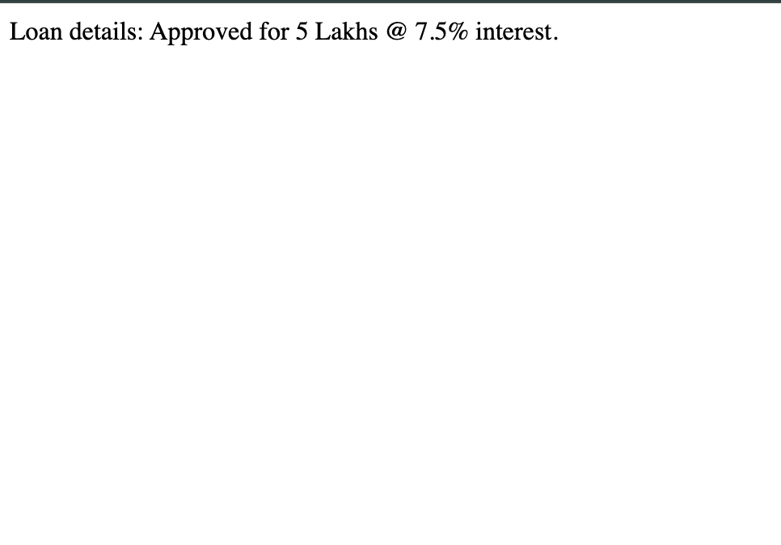
And then visit http://localhost:8761/ on your browser to see the instance status.Note:The server of eurekaserver,account and loan application should start.
